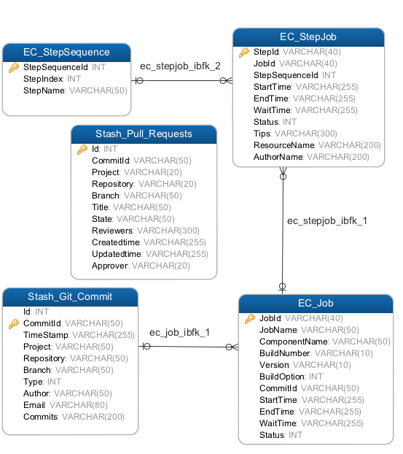

Table - EC_Job

|  |  |  |  |  |  |
| --- | --- | --- | --- | --- | --- |
| Name | Code | Data Type | Length | Primary | Foreign Key |
| JobId | JOBID | varchar(40) | 40 | TRUE | FALSE |
| JobName | JOBNAME | varchar(50) | 50 | FALSE | FALSE |
| ComponentName | COMPONENTNAME | varchar(50) | 50 | FALSE | FALSE |
| BuildNumber | BUILDNUMBER | varchar(10) | 10 | FALSE | FALSE |
| Version | VERSION | varchar(10) | 10 | FALSE | FALSE |
| BuildOption | BUILDOPTION | int |  | FALSE | FALSE |
| CommitId | COMMITID | varchar(50) | 50 | FALSE | TRUE |
| StartTime | STARTTIME | datetime |  | FALSE | FALSE |
| EndTime | ENDTIME | datetime |  | FALSE | FALSE |
| WaitTime | WAITTIME | datetime |  | FALSE | FALSE |
| Status | STATUS | int |  | FALSE | FALSE |

Table - EC_StepJob

|  |  |  |  |  |  |
| --- | --- | --- | --- | --- | --- |
| Name | Code | Data Type | Length | Primary | Foreign Key |
| StepId | STEPID | varchar(40) | 40 | TRUE | FALSE |
| JobId | JOBID | varchar(40) | 40 | FALSE | TRUE |
| StepSequenceId | STEPSEQUENCEID | int |  | FALSE | TRUE |
| StartTime | STARTTIME | datetime |  | FALSE | FALSE |
| EndTime | ENDTIME | datetime |  | FALSE | FALSE |
| WaitTime | WAITTIME | datetime |  | FALSE | FALSE |
| Status | STATUS | int |  | FALSE | FALSE |
| Tips | TIPS | nvarchar(300) | 300 | FALSE | FALSE |
| ResourceName | RESOURCENAME | nvarchar(20) | 20 | FALSE | FALSE |
| AuthorName | AUTHORNAME | nvarchar(20) | 20 | FALSE | FALSE |

Table - EC_StepSequence

|  |  |  |  |  |  |
| --- | --- | --- | --- | --- | --- |
| Name | Code | Data Type | Length | Primary | Foreign Key |
| StepSequenceId | STEPSEQUENCEID | varchar(40) | 40 | TRUE | FALSE |
| StepIndex | STEPINDEX | int |  | FALSE | FALSE |
| StepName | STEPNAME | nvarchar(50) | 50 | FALSE | FALSE |

Table - Stash_Git_Commit

|  |  |  |  |  |  |
| --- | --- | --- | --- | --- | --- |
| Name | Code | Data Type | Length | Primary | Foreign Key |
| Id | ID | int(10) | 40 | TRUE | FALSE |
| CommitId | COMMITID | varchar(50) | 50 | FALSE | FALSE |
| TimeStamp | TIMESTAMP | datetime |  | FALSE | FALSE |
| Project | PROJECT | varchar(50) | 50 | FALSE | FALSE |
| Repository | REPOSITORY | varchar(50) | 50 | FALSE | FALSE |
| Branch | BRANCH | varchar(50) | 50 | FALSE | FALSE |
| Type | TYPE | int |  | FALSE | FALSE |
| Author | AUTHOR | nvarchar(50) | 50 | FALSE | FALSE |
| Email | EMAIL | varchar(80) | 80 | FALSE | FALSE |
| Commits | COMMITS | nvarchar(200) | 200 | FALSE | FALSE |

Table - Stash_Pull_Requests

|  |  |  |  |  |  |
| --- | --- | --- | --- | --- | --- |
| Name | Code | Data Type | Length | Primary | Foreign Key |
| Id | ID | int(10) | 10 | TRUE | FALSE |
| CommitId | COMMITID | varchar(50) | 20 | FALSE | FALSE |
| Project | PROJECT | varchar(20) | 20 | FALSE | FALSE |
| Repository | REPOSITORY | varchar(50) | 50 | FALSE | FALSE |
| Branch | BRANCH | varchar(50) | 50 | FALSE | FALSE |
| Title | TITLE | varchar(50) | 50 | FALSE | FALSE |
| State | STATE | varchar(50) | 50 | FALSE | FALSE |
| Reviewers | REVIEWERS | nvarchar(300) | 300 | FALSE | FALSE |
| Createdtime | CREATEDTIME | datetime |  | FALSE | FALSE |
| Updatedtime | UPDATEDTIME | datetime |  | FALSE | FALSE |
| Approver | APPROVE | varchar(20) | 20 | FALSE | FALSE |

CREATE TABLE EC_Job

(

JobId varchar(40) not null ,

JobName varchar(50),

ComponentName varchar(50),

BuildNumber varchar(10),

Version varchar(10),

BuildOption int,

CommitId varchar(50),

StartTime datetime,

EndTime datetime,

WaitTime datetime,

Status int,

primary key(JobId),

FOREIGN KEY (CommitId) REFERENCES Stash_Git_Commit (CommitId)

)

CREATE TABLE EC_StepJob

(

StepId varchar(40) not null,

JobId varchar(40),

StepSequenceId int,

StartTime datetime,

EndTime datetime,

WaitTime datetime,

Status int,

Tips nvarchar(300),

ResourceName nvarchar(200),

AuthorName nvarchar(200),

primary key(StepId ),

FOREIGN KEY (JobId) REFERENCES EC_Job (JobId),

FOREIGN KEY (StepSequenceId) REFERENCES EC_StepSequence (StepSequenceId)

)

CREATE TABLE EC_StepSequence

(

StepSequenceId int,

StepIndex int,

StepName varchar(50),

primary key(StepSequenceId)

)

CREATE TABLE Stash_Git_Commit

(

Id int,

CommitId varchar(50) not null,

TimeStamp datetime,

Project varchar(50),

Repository varchar(50),

Branch varchar(50),

Type int,

Author varchar(50),

Email varchar(80),

Commits nvarchar(200),

primary key(CommitId)

)

CREATE TABLE Stash_Pull_Requests

(

Id int,

CommitId varchar(50) not null,

Project varchar(20),

Repository varchar(20),

Branch varchar(50),

Title varchar(50),

State varchar(50),

Reviewers nvarchar(300),

Createdtime datetime,

Updatedtime datetime,

Approver varchar(20),

primary key(Id)

)





